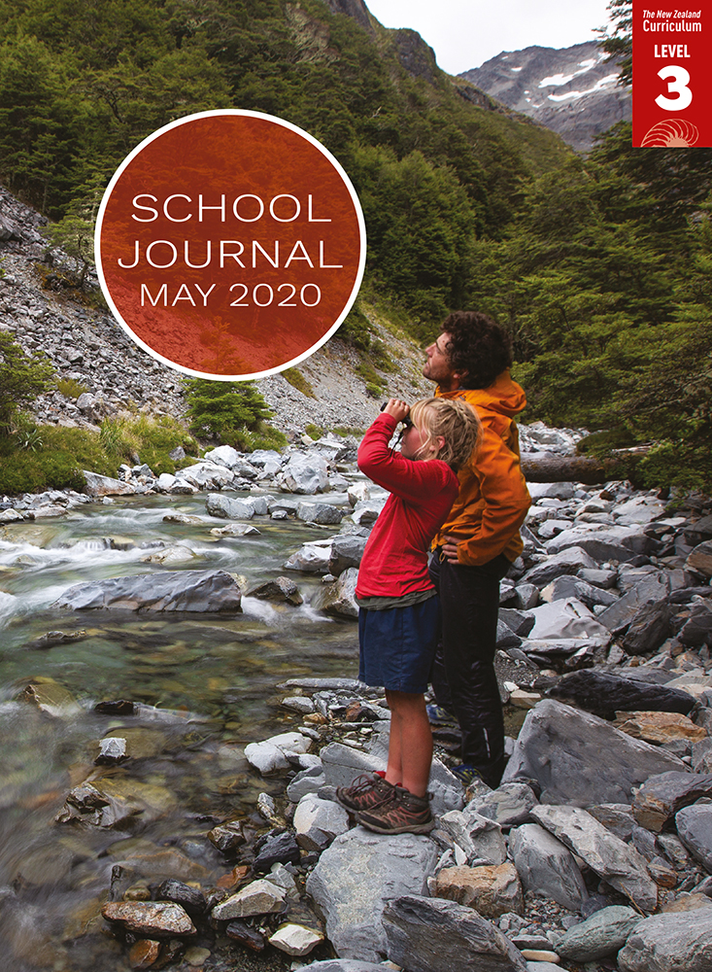

School Journal

Level 3, May 2020

**Year 5**

# The Longest Walk

by Rebekah White

[TheLearning Progression Frameworks](https://curriculumprogresstools.education.govt.nz/lpf-tool/) describe significant signposts in reading and writing as students develop and apply their literacy knowledge and skills with increasing expertise from school entry to the end of year 10.

## Overview

The Rapsey family, including nine-year-old Elizabeth and her six-year-old brother, Johnny, spent just over four months walking the entire length of New Zealand. During this time, they lived a simple life, learning about the natural world around them and the various ways to engage with it. Rebekah White captures both the sense of adventure and the contemplative moments through her lyrical style, which contains some elements of creative non-fiction.

A PDF of the text is available at [www.schooljournal.tki.org.nz](http://www.schooljournal.tki.org.nz)

## Themes

* Journeys
* Perseverance and determination
* The importance of family

## Related texts

“**Boy on a Bike**” SJ L3 May 2015 | “**Wildboy: The Journey of Brando Yelavich**” SJ L4 May 2016 | ***Diary of a Wildboy*** SJSL L4 2016

## Strengthening reading behaviours (what to notice)

|  |  |
| --- | --- |
| Text structure and features | Requiring students to: |
| * Metaphor and other figurative or connotative language * Flashbacks or time shifts * Non-English words, including te reo Māori place names * Varied sentence types | * draw on their prior knowledge of figurative language features and the context to interpret the intended meaning * look for clues that provide information about the timing of the events and the context and that suggest the writer has deliberately chosen to set the scene this way * use their prior knowledge of te reo Māori, New Zealand’s geography, and place names, as well as the map provided in the text and other resources, to understand the position of each place mentioned in the article * notice punctuation and its effect on phrasing and meaning. |

|  |  |
| --- | --- |
| Vocabulary | |
| Possibly unfamiliar words and phrases | tussock, saddle, mountain passes, suburban, ancient, kōkako, skipped, occasionally, boulders, pyramid, beech, pass, clamber, flora, moraine, dulled, calculations, scree, dislodge, estuary, brace, scoffs |
| Place names, including many in te reo Māori | Travers Saddle, Te Araroa, Nelson Lakes, Cape Rēinga, Northland, Waikato, Pureora, Mount Ngāuruhoe, Mount Tongariro, Whanganui, Sabine Valley, Rotomairewhenua, Lake Constance, Southland, Invercargill, Bluff, Rakiura, Antarctica |
| Figurative language | split in half like apples, the water looks like air with a colour, the roar and slam of the wind, small town looks like it’s floating, stacked like Lego, the day is fading |
| Helpful prior knowledge (pre-reading and introducing the text) | |
| * Non-fiction can be told creatively like a story. * Aotearoa New Zealand has unique natural environments, and many people enjoy tramping through them. * Aotearoa New Zealand has a varied geography. | |

## Possible reading and writing purposes

* Find out about the challenges and joys of walking the length of Aotearoa New Zealand
* Identify why the family chose to walk the length of Aotearoa New Zealand and discuss the impact of the journey on the family
* Identify the features of creative non-fiction that the author has used
* Evaluate the author’s deliberate text structure and language decisions
* Organise, record, and communicate information and ideas from the text

See *Effective Literacy Practice in Years 5–8* for information about teaching comprehension strategies ([Teaching comprehension](http://literacyonline.tki.org.nz/Literacy-Online/Planning-for-my-students-needs/Effective-Literacy-Practice-Years-5-8/Teaching-comprehension)) and for suggestions on using this text with your students ([Approaches to teaching reading](http://literacyonline.tki.org.nz/Literacy-Online/Planning-for-my-students-needs/Effective-Literacy-Practice-Years-5-8/Approaches-to-teaching-reading)).

## Possible curriculum contexts

This text has links to level 3 of the New Zealand Curriculum in:[**ENGLISH**](http://nzcurriculum.tki.org.nz/The-New-Zealand-Curriculum/English)[**HEALTH AND PHYSICAL EDUCATION**](http://nzcurriculum.tki.org.nz/The-New-Zealand-Curriculum/Health-and-physical-education)

## Understanding progress

The following aspects of progress are taken from the [Learning Progression Frameworks](https://curriculumprogresstools.education.govt.nz/lpf-tool/) and relate to the specific learning tasks below. See the LPFs for more about how students develop expertise and make progress in these aspects:

* Acquiring and using information and ideas in informational texts
* Making sense of text: using knowledge of text structure and features
* Writing meaningful text: using knowledge of text structure and features
* Creating texts to communicate current knowledge and understanding.

## Strengthening understanding through reading and writing

The *School Journal* provides rich texts that can be returned to many times. The following suggestions are based on the premise that rereading the text is a fundamental part of developing students’ understanding and reading skills. **Select from and adapt** them, according to your students’ strengths, needs, and experiences.   
Note: Most of these activities lend themselves to students working in pairs or small groups.

* Have the students reread the text, encouraging them to note any questions that remain unanswered. Record these on stickies, for example, “How did they count crossing Cook Strait?”, “Where did their food come from?”, “Why did they have to walk on busy highways?”, “Did they get lost?”, “Did they have a day off?”. Have them make up answers in an interview format or a hot seat, with students acting as the characters and creating answers to the questions.
* Use a PMI (plus/minus/interesting) chart to organise the challenges and joys of walking the length of Aotearoa New Zealand. The students could add a summary response, for example, “Overall I think this journey was … because …”
* Locate and summarise ideas. For example, the students could find three reasons why the family did this walk, three highlights, three low points, and three new discoveries. Alternatively, they could find three things they would have found interesting or challenging or things they want to find out more about.
* Ask the students to recount or describe, orally or in writing, a family journey, a challenging situation, a time when perseverance was needed, or a special time with their family.
* Analyse and discuss the creative non-fiction style of writing this author has used. Have the students use the **Features of creative non-fiction** template provided to find examples, such as adjectival phrases (frozen air, long breaths, emerald-coloured lakes), figurative language (split in half like apples, stacked like Lego), subject-specific vocabulary (tussock, saddle), sensory descriptions (Inside the cloud, it’s very quiet), and dialogue. For students who require further support, model some examples first.
* Have students rewrite a non-fiction article as creative non-fiction. This could include writing about travel, nature, science, or sport.
* Clarify the meaning of any unfamiliar vocabulary. The students could find five words that were new to them, tricky to say, or difficult to understand. They could use a template to record information about the word, such as how it was supported in the article, any synonyms (using a thesaurus), and the definition (using a dictionary). They could also write their own sentence with the word. English language learners could translate the word into their first language.
* For more ideas and strategies to support English language learners, see [ESOL Online](https://esolonline.tki.org.nz/).

“The Longest Walk” Features of creative non-fiction

|  |  |
| --- | --- |
| **Features** | **Examples from the text** |
| Factual information |  |
| Adjectival phrases (a group of words that describe a noun or pronoun) |  |
| Figurative language (for example, similes, metaphors, hyperbole, and personification that make writing interesting) |  |
| Subject-related vocabulary |  |
| Visual descriptions |  |
| Dialogue |  |
| I think the important differences between creative non-fiction and non-fiction writing are: | |